Testing the Denford 8250: Frequency Response

IASCA cd on repeat on track 28 (Pink Noise) using an rca to XLR cable into an M-Audio Mobile Pre soundcard.
Setting: Flat
Vol: 10/32

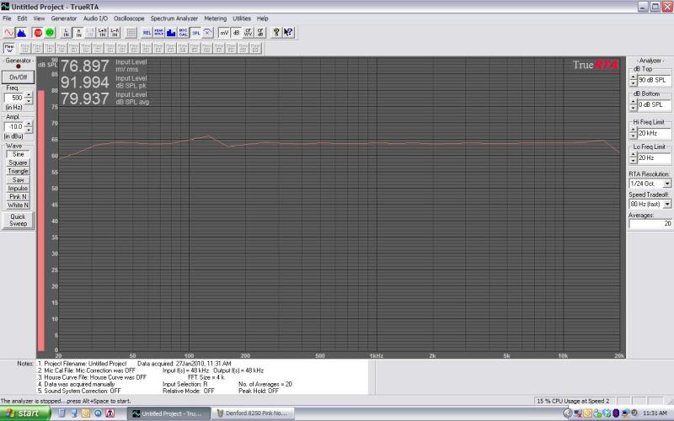

Setting: Flat
Vol: 20/32

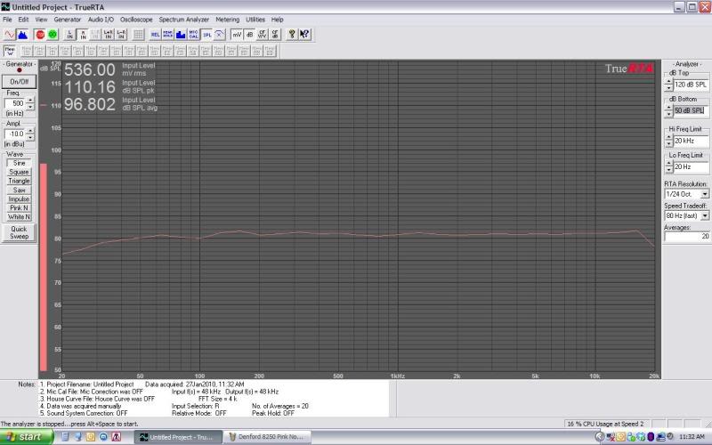

Setting: Flat
Vol: 32/32
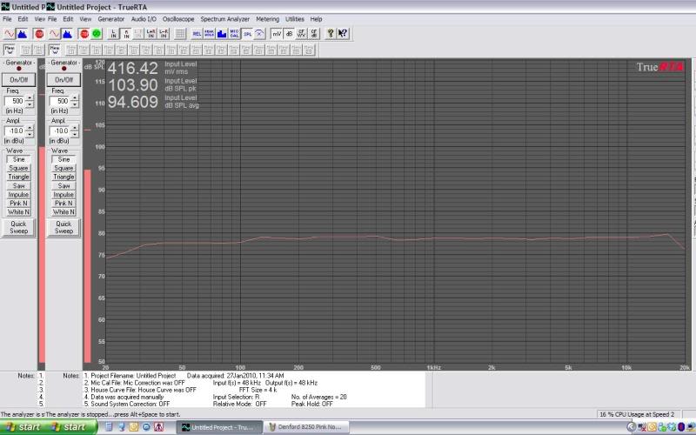

Setting: Treble +12 (max). Bass 0.
Vol: 15/32
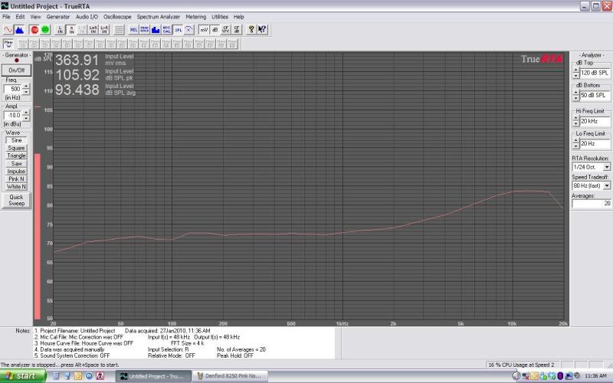

Setting: Treble: 0. Bass +12 (max)
Vol: 15/32
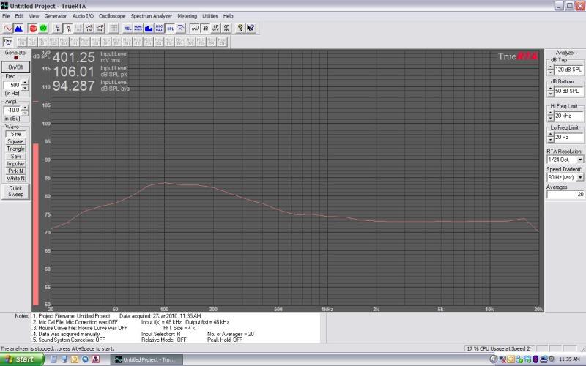

Setting: Treble: -12 (min). Bass -12 (min)
Vol: 15/32
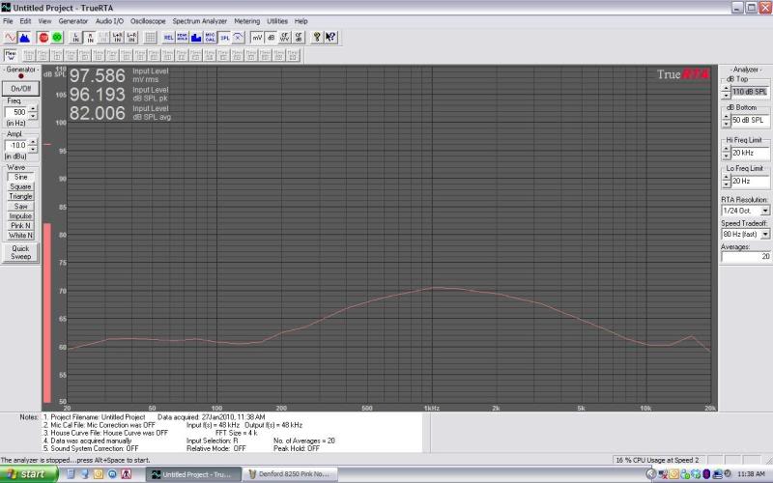

Setting: Treble: +12 (max). Bass +12 (max)
Vol: 15/32
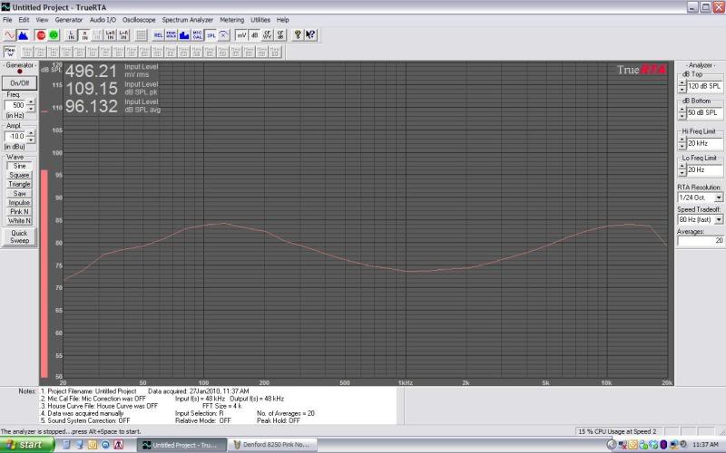
The fall on both end of the spectrum are artifacts from my measurement setup.
This HU is ruler flat.

Original: http://www.diymobileaudio.com/forum/member-reviews-product-comparisons/74328-testing-denford-8250-frequency-response.html

